Sarah CTO Cloud assignment.

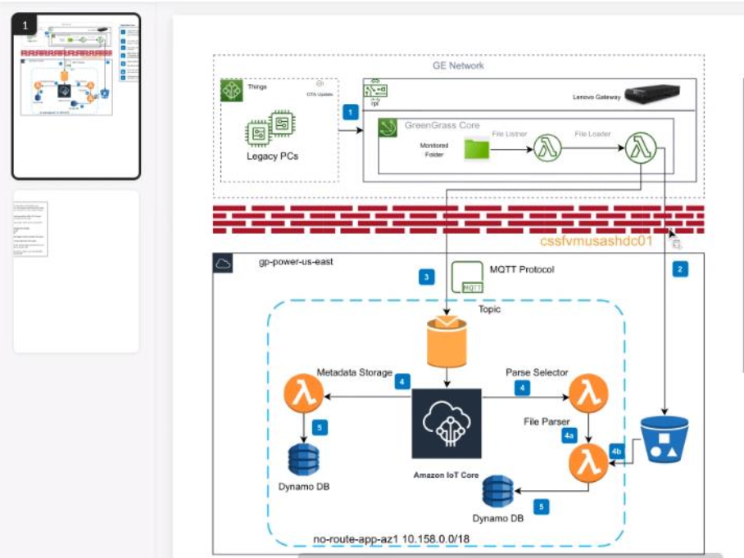

1. There is Unique Application Identifier for each resource. This help us understand which application is the resource tagged to. We type the UAI in Service Now for this purpose.
2. In theory I can look into architectural diagram to see the resources tagged to the application.
3. I need to see if I can find any difference between the two, if any application is untagged by writing code in lambda or cli.

I need to come up with a design and automate the process to make sure that when script is run on particular application, the result should be that every resource is tagged and when you compare it with actual architecture, it should be same, there should be no miss out; otherwise it will go to audit. Need to see a scripting language to verify all resources are tagged.

If you pull the design and see the output, both should be same. This is basically comparing the architecture with output of the script that should return that all resources are being tagged.